Module 5:

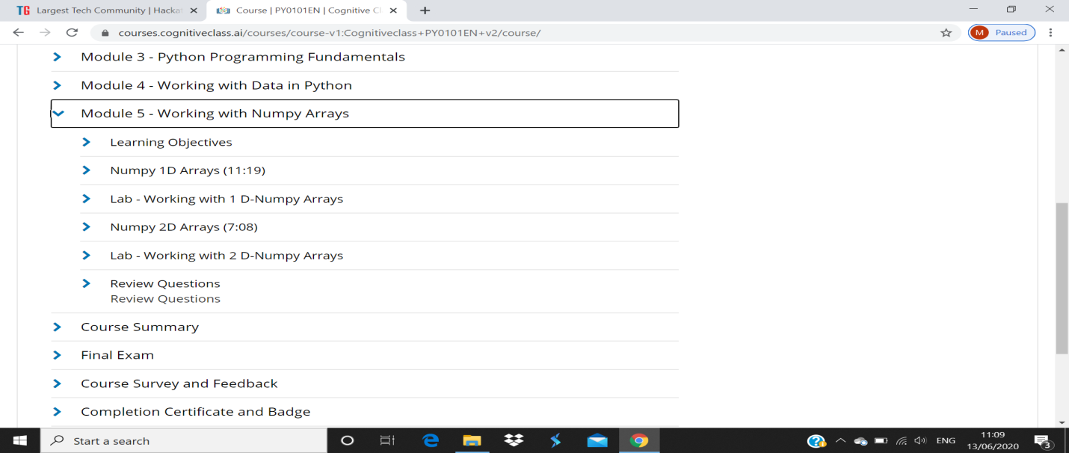

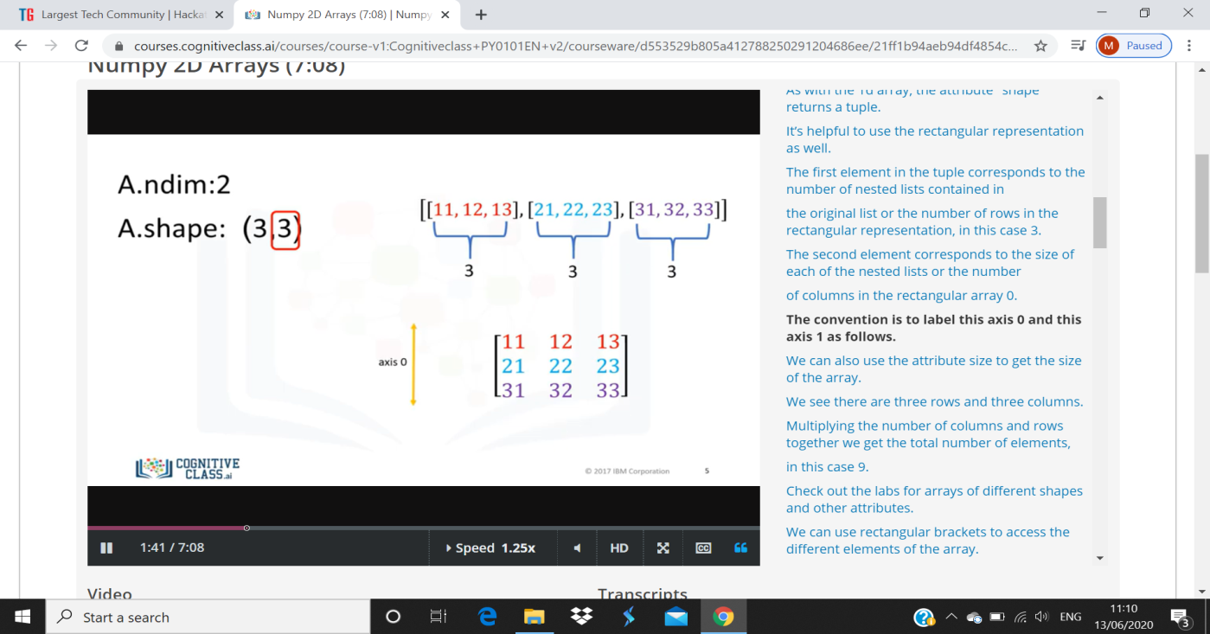

The first element in the tuple corresponds to the number of nested lists contained inthe original list or the number of rows in the rectangular representation, in this case 3.The second element corresponds to the size of each of the nested lists or the numberof columns in the rectangular array 0.The convention is to label this axis 0 and this axis 1 as follows.We can also use the attribute size to get the size of the array.We see there are three rows and three columns.Multiplying the number of columns and rows together we get the total number of elements,in this case 9.